Step 1:
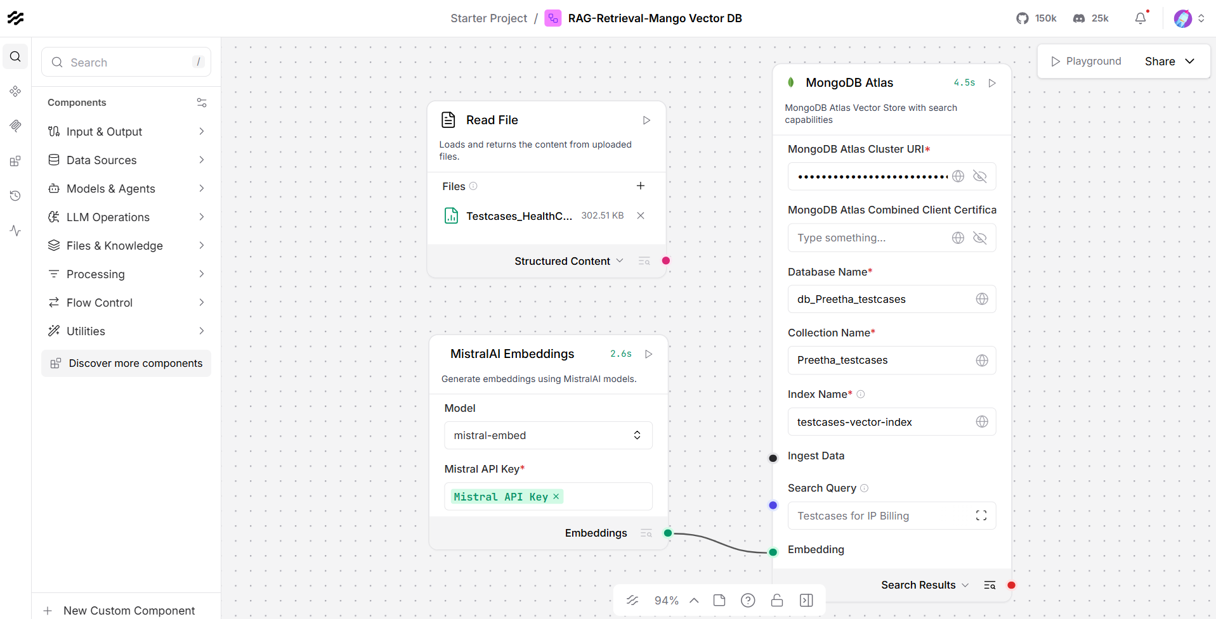
Step2: Search Query: Testcases for IP Billing run the langflow flow
Step 3: Testcases are fetched related to IP Billing
